**Strings Logical Questions in JavaScript**

Q-1. Given a string **str**containing only lower case alphabets, the task is to sort it in lexicographically-descending order.

**Sample Input :**

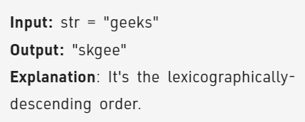

Q-2. Given a string **S**, Check if characters of the given string can be rearranged to form a palindrome.  
**Note:**You have to return 1 if it is possible to convert the given string into palindrome else return 0.

**Sample Input :**

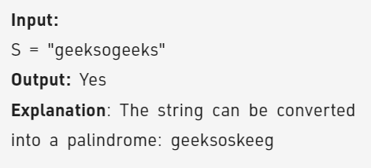

Q-3. In this problem, a String **S** is composed of lowercase alphabets and wildcard characters i.e. '**?'.** Here, '?' can be replaced by any of the lowercase alphabets. Now you have to classify the given String on the basis of following rules:

If there are more than **3 consonants together or more than 5 vowels together**, the String is considered to be "**BAD**". A String is considered "**GOOD" only if it is not “BAD”**.

**NOTE:**String is considered as "BAD" if the above condition is satisfied even once. Else it is "GOOD" and the task is to make the string "BAD".

**Sample Input :**

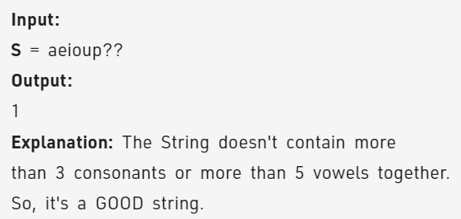

Q-4. Given a String S, reverse the string without reversing its individual words. Words are separated by dots.

**Sample Input :**

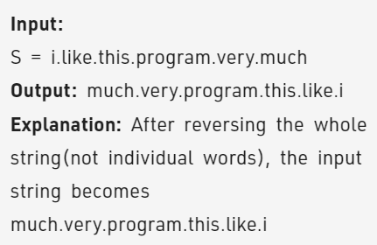

Q-5. Given a string **S**, check if it is palindrome or not.

**Sample Input :**

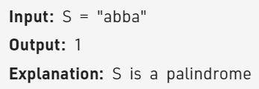

Q-6. Given a string **S** consisting of **lowercase**Latin Letters. Return the first non-repeating character in S. If there is no non-repeating character, return **'$'.**

**Sample Input :**

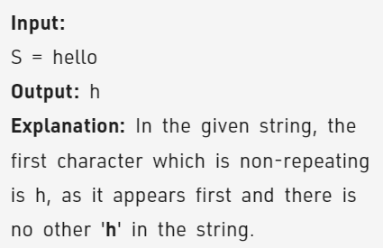

Q-7. Given a string, our task is finding the occurrence of a character in the string with the help of user-defined function.

**Sample Input :**

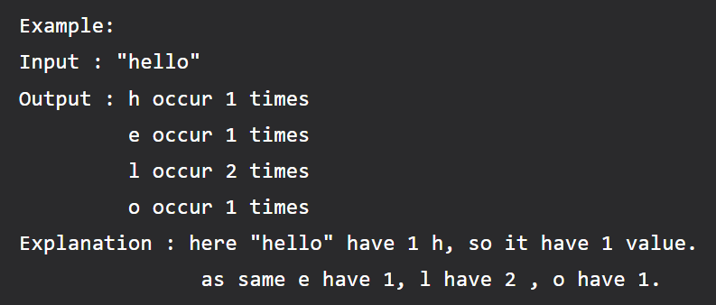

Q-8. Given a string S, the task is to remove all the duplicates in the given string.

Below are the different methods to remove duplicates in a string.

**Sample Input :**

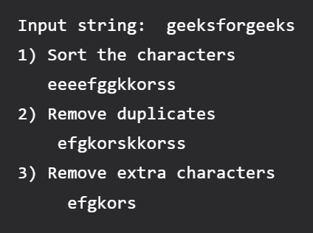

Q-9. Given a string str, find the length of the longest substring without repeating characters.

**Sample Input :**

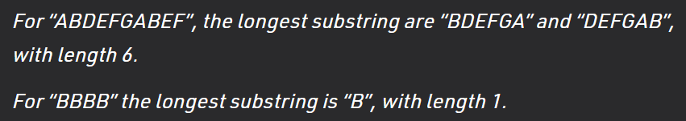

Q-10. Two strings are said to be isomorphic if it is possible to map every character of the first string to every character of the second string. Basically, in isomorphic strings, there is a one-to-one mapping between every character of the first string to every character of the second string.

**Sample Input :**

